**ASSIGNMENT: 1 DATE:**

1) Write a C program multiply two n*n matrices.

2) Write a C program to Fibonacci series up to nth.

3) Write a C program to find if a number is a prime or non-prime number.

4) Write a C program to find the factorial of a number.

**Source Code:**

**1)**

#include<stdio.h>

#define MAX 10

int count=0;

int main()

{

int A[MAX][MAX],B[MAX][MAX],C[MAX][MAX];

int c,d,k,N,sum=0;

printf("ENTER VALUE OF N: ");

scanf("%d",&N);

printf("FOR MATRIX A ");

printf("ENTER ELEMENTS INTO YOUR MATRIX\n");

for(c=0;c<N;c++)

{

count++;//for the loop

for(d=0;d<N;d++)

{

count++;//for the loop

scanf("%d",&A[c][d]); count++;//for the loop

}

}

printf("FOR MATRIX B ");

printf("ENTER ELEMENTS INTO YOUR MATRIX\n");

for(c=0;c<N;c++)

{

count++;//for the loop

for(d=0;d<N;d++)

{

count++;//for the loop

scanf("%d",&B[c][d]); count++;//for the loop

}

}

for ( c = 0 ; c < N ; c++ )

{

count++;//for the loop

for ( d = 0 ; d < N ; d++ )

{

count++;//for the loop

for ( k = 0 ; k < N ; k++ )

{

count++;//for the loop

sum = sum + A[c][k]*B[k][d]; count++;//for the assignment

}

C[c][d] = sum; count++;//for the assignment

sum = 0; count++;//for the assignment

}

}

printf("\nAFTER MULTIPLYING A AND B\n");

for(c=0;c<N;c++)

{

count++;//for the loop

for(d=0;d<N;d++)

{

printf("%d ",C[c][d]);count++;//for the printf

}

printf("\n");count++;//for the printf

}

printf("\nSTEP COUNT: %d\n",count);

}

**Output:**

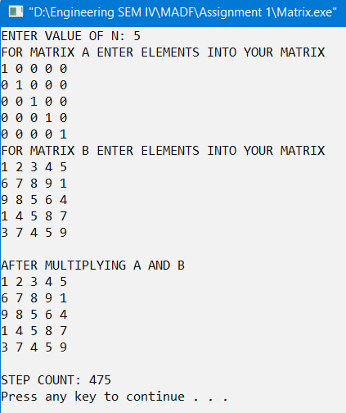

**2)**

#include<stdio.h>

int count=0;

int main()

{

int a=0,b=1,i,n,c;

printf("ENTER THE VALUE OF N: ");

scanf("%d",&n);

switch(n)

{

case 1:

count++; //count for case 1

printf("0");

break;

case 2:

count++; //count for case 2

printf("1");

break;

default:

count++; // count for default case

printf("0 1");

}

for(i=2;i<n;i++)

{

count++; //count for the for loop

c=a+b; count++; //ount for the assignment

printf(" %d",c); count++; //print count

a=b; count++; //assignment count

b=c; count++; //assignment count

}

count++; //last test case count of the loop

}

**Output:**

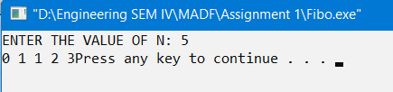

**3)**

#include<stdio.h>

int count=0;

int main()

{

int flag=0,i,n;

printf("ENTER THE VALUE OF N: ");

scanf("%d",&n);

count++; //for the if condition

if(n==0||n==1)

{

count++;//for the assignment

flag=1;

}

for(i=2;i<n;i++)

{

count++;/// for the loop

if(n%i==0)

{

count++;// for the if condition

flag=1; count++;//for the assignment

break;

}

}

count++;// for the last test case of the loop

count++//for the if condition

if(flag==0)

printf("IT IS A PRIME NUMBER\n");

else

printf("IT IS NOT A PRIME NUMBER\n");

printf("\nSTEP COUNT= %d\n",count);

}

**Output:**

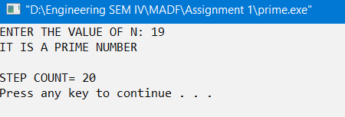

**4)**

#include<stdio.h>

int count=0;

int main()

{

int i,fact=1,n;

printf("ENTER THE VALUE OF N: ");

scanf("%d",&n);

for(i=1;i<=n;i++)

{

count++; //counter for the loop

fact=fact*i;count++; //counter for the assignment

}

count++;//counter for the last test case

printf("FACTORIAL OF %d is %d\n",n,fact);

printf("STEP COUNT= %d\n",count);

}

**Output:**

